Glass Transition Temperature Prediction in Lignin Polyurethanes Using Machine Learning on Small Experimental Dataset

Silviu Florin Acaru¹, Marc Comí², Panagiotis Falireas², Danny E. P. Vanpoucke^{3,4}, Richard Vendamme², Katrien V. Bernaerts¹*
¹ Sustainable Polymer Synthesis group, Aachen-Maastricht Institute for Biobased Materials (AMIBM), Faculty of Science and Engineering, Maastricht University, Brightlands Chemelot Campus, Urmonderbaan 22, 6167 RD Geleen, the Netherlands
² Sustainable Polymer Technologies Team, Flemish Institute for Technological Research (VITO N.V.), Mol, Belgium
³ Hasselt University, Institute for Materials Research (imo-imomec), Quantum & Artificial inTelligence design Of Materials (QuATOMs), Martelarenlaan 42, B-3500 Hasselt, Belgium
⁴ imec, imo-imomec, Wetenschapspark 1, B-3590 Diepenbeek, Belgium

* corresponding author, katrien.bernaerts@maastrichtuniversity.nl

Keywords: lignin; polyurethane; machine learning; small dataset

Abstract: Lignin-based polyurethanes (PUs) offer a compelling route towards sustainable material development, yet the challenge of designing chemical formulations with targeted properties, such as glass transition temperature (T_{g}), remains unresolved. In this work, we present a systematic approach, to explore key structural parameters—such as lignin content, polyol chain length, isocyanate functionality, and mixing ratios—across 136 unique formulations, creating a diverse dataset of lignin-based PUs. By harnessing this small dataset, we develop a machine learning (ML) ensemble model capable of accurately predicting T_{g}, with a mean absolute error of just 6.66°C on the validation set, surpassing the performance of conventional regression methods. Additionally, we enhance model interpretability by integrating advanced mapping techniques and employ an adaptive grid search algorithm to explore extrapolative scenarios. Our workflow, paired with a user-friendly interface, enables rapid discovery and optimization of formulations with desired properties. This study not only deepens the understanding of structure-property relationships in lignin-PUs but also provides a scalable ML-driven tool for designing sustainable materials with precision, highlighting the transformative potential of artificial intelligence in green chemistry and materials innovation.

Graphical abstract
A machine learning ensemble accurately predicts glass transition temperatures for lignin-based polyurethanes within 6.66°C, despite being trained on a dataset of only 136 formulations. The model efficiently combines seven key features to overcome this data limitation. This optimized workflow generated over 4 million novel lignin-polyurethane formulations, with an intuitive interface accelerating the adoption of sustainable polyurethanes.

Introduction
The global polyurethane (PU) industry is experiencing growing pressure to develop environmentally friendly and bio-based alternatives in response to ecological concerns. This shift is driven by the increasing demand for high-performance materials in sectors like construction, automotive, furniture, and footwear, where sustainability has become a key priority.^{[1]}
Historically, the creation of new materials has been a laborious process, heavily reliant on extensive laboratory experimentation. While crucial for material innovation, this conventional approach often proves inefficient, lengthy, and expensive. A prime example is the challenge of regulating thermomechanical properties in PUs, which necessitates multiple experiments to adjust ingredient proportions, catalysts, and production methods, potentially hindering the rapid commercialization of new materials.^{[2–7]}
Recent progress in data-centric methodologies, however, offers a promising avenue for expediting PU discovery. The field of materials science has seen a surge in the application of artificial intelligence (AI) and machine learning (ML) techniques. Researchers are now employing sophisticated algorithms to forecast polymer structures and properties with remarkable precision, thereby reducing the need for costly physical experiments.^{[8,9]} These models achieve this by automating the prediction of critical performance metrics such as the glass transition property (T_{g}), even when working with sparse datasets.^{[10–13]}
Despite these advancements, not all ML methods can deal effectively with small experimental datasets. One of the primary limitations of traditional ML algorithms is their tendency to overfit when data is limited, meaning the model captures noise rather than underlying patterns.^{[14]} This issue becomes particularly significant when developing advanced materials like PUs, where small deviations in formulation can lead to large variations in performance metrics. Furthermore, certain models struggle with capturing non-linear relationships that are often present in experimental datasets, requiring more sophisticated approaches to make accurate predictions from limited data.^{[15]}
To overcome these limitations, ensemble methods have emerged as powerful tools. These ML techniques combine multiple models, known as base learners, to improve prediction accuracy and robustness. Random Forests (RF), for instance, construct multiple decision trees and aggregate their predictions. Tao et al., evaluated 79 different ML models to predict the T_{g} of polymers, using various polymer representations and feature engineering approaches. RF models were among the top performers, particularly when using a polymer's repeat unit as the structural representation.^{[16]} Ensemble models using polynomial base models have also been shown to improve prediction accuracy, moreover, in contrast to RF-based models, the final predictive model can be reformulated as a single model instance significantly improving computational efficiency at production level.^{[17]} Such models were successfully used for designing hyperbranched polymers as dispersing agents in inks.^{[18]} Gradient Boosting Regression (GBR), another powerful ensemble method, has also proven effective in materials informatics. Unlike RF, which builds trees in parallel, GBR constructs trees sequentially, with each new tree correcting the errors of the previous ones. Albuquerque et al. used GBR to analyze various formulations of biobased epoxy resins.^{[19]} However, the limited dataset in that study (35 samples) resulted in significant overfitting, highlighting the need for more robust approaches to handle small data scenarios.
In addressing the challenges, this study proposes an innovative approach that combines domain expertise with ensemble ML techniques for optimizing sustainable, lignin-based PUs. Traditional methods such as cross-validation and hyperparameter tuning are effective for refining individual models, but ensemble approaches—like stacking and bagging—offer the advantage of improving overall performance by leveraging multiple algorithms. Stacking, for instance, uses a meta-model to combine the predictions of various base models, which has been shown to significantly enhance predictive accuracy. Esmaeili et al. applied this technique to improve the prediction of polymer solubility parameters by integrating Support Vector Machines (SVMs), Neural Networks (NNs), and RFs, with a linear regressor serving as the meta-model.^{[20]} Similarly, bagging, which trains models on random subsets of the data to reduce variance, has proven effective for managing heterogeneous datasets. The utility of bagging was demonstrated for improving the prediction of polymer mechanical properties and the robustness of polymer degradation models, respectively.^{[21,22]}
This study builds on these advancements by combining stacking and bagging techniques with domain-specific knowledge to enhance the predictive accuracy and formulation optimization of lignin-based PUs. A range of models - linear (e.g., Lasso, ElasticNet), kernel-based (e.g., SVMs), and tree-based (e.g., RF, GBR) - are employed to capture both linear and non-linear relationships within the data. Linear models, in particular, have shown consistent performance in polymer research.^{[23,24]} By integrating the strengths of these diverse models, the proposed approach seeks to establish more reliable data driven structure-property relationships and improve the prediction accuracy of sustainable PU formulations, particularly when working with small experimental datasets. A user-friendly interface that incorporates the model as its core is introduced, enabling chemists to visualize recipe formulations based on desired properties, exemplified by the T_{g}. This interface simplifies the interaction with the model, removing the need for chemists to have in-depth knowledge of ML techniques and allowing them to focus on leveraging its capabilities with ease.
The central research question guiding this study is: Can ML models, in combination with domain expertise, effectively predict and optimize the formulations of sustainable, lignin-based PUs, especially in the context of limited data?

Materials and Methods

Lignin PU Experiments

Materials
All commercially available solvents, reagents, and chemicals were used as received without further purification unless otherwise stated. Polytetrahydrofurans (PTHF_{s}) with M_{n}= 250, 650 and 1000 g/mol and corresponding OH values of 8.68, 3.20 and 2.10 mmol/g, were purchased from Merck Life Sciences. Stannous octoate (Sn(Oct)₂) was purchased from Alfa Aesar, while methyl ketone (MEK) and anhydrous tetrahydrofuran (THF) was purchased from VWR chemicals. Hexamethylene diisocyanate (HDI) and NCO trimer Desmodur® ultra N 3600 (further mentioned as "HDI trimer" (HDIt), f_{NCO}~3.5 isocyanate groups/molecule) was purchased from Covestro.

Construction of the Dataset
A total of 180 lignin-based PU films were prepared with different structural characteristics by changing relevant parameters in the formulation. Four main structural parameters during the PU fabrication were modified: (1) the amount of lignin in the polyol mixture, (2) the length of the co-polyol polytetrahydrofuran (PTHF), (3) the type and functionality of the isocyanate and (4) the mixing ratio of isocyanate to polyol. As observed in Figure 1, lignin-based PUs were fabricated to present different thermal behavior by exchanging the lignin content in the polyol mixture (Parameter 1), the molar mass of the co-polyol PTHF (Parameter 2), the functionality of the isocyanate used for the synthesis (Parameter 3) and the mixing ratio (Ratio=[NCO_{(HDI or HDIt)}]/[OH_{(lignin + PTHF)}] (Parameter 4). Regarding the latter, the use of either a difunctional isocyanate HDI or HDIt created two main groups of specimens whereas in each group five subgroups were created by gradually increasing the mixing ratio from 0.6 to 1.4. Each subgroup synthesized with a particular ratio was further split into 3 subgroups by using PTHF of molar mass 250, 600 and 1000 g/mol where the impact of the polyol length was examined. Finally, each subgroup formulated with a certain isocyanate, mixing ratio, and PTHF was further divided in 5 final subgroups by changing the lignin content in the polyol mix. In all cases, the same batch of extracted kraft lignin (EKL) was used. 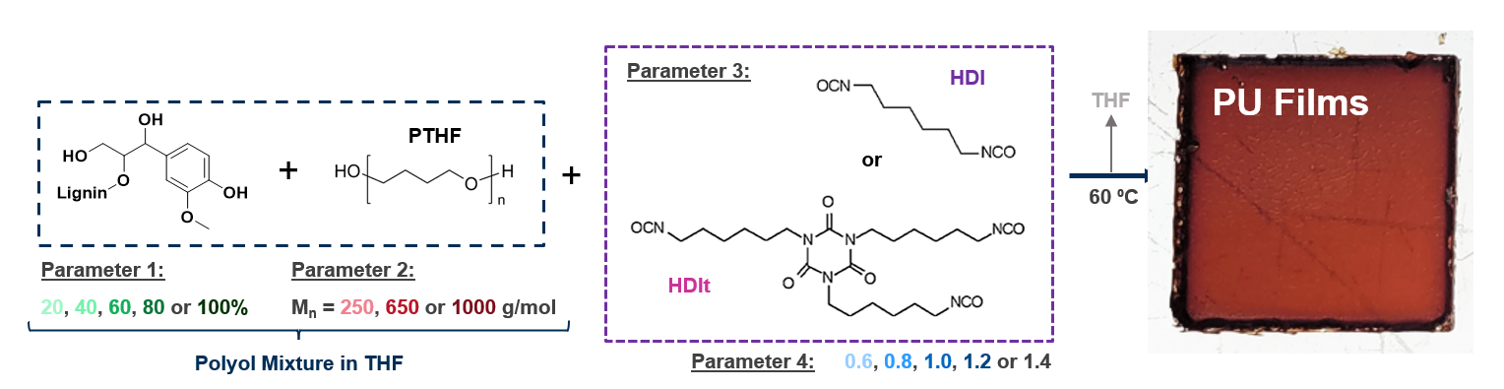
Figure 1 Scheme representing the 4 structural parameters modified during the preparation to obtain the 150 PUs.

Synthesis Procedure
EKL: in a three neck 2 L round bottom flask equipped with mechanical stirring, 800 g of technical MEK was added to 200 g of Kraft lignin powder. The mixture was stirred (200 rpm) at room temperature (22 °C) for 16 hours. After, a basic filtration under gravity was used to remove the insoluble fraction. The filtrate containing the EKL in MEK solution was dried under vacuum and in the oven at 45°C for 4 h. EKL is characterized by an OH value of 6.42 mmol/g and M_{n} = 1590 g/mol and a dispersity of Ð = 1.9 (as determined from GPC in THF calibrated with PS standards).
PU fabrication: the series of PU films were prepared at various EKL to PTHF mass ratios (polyol mixture) using either HDI or HDIt as isocyanate comonomer, according to equation 1.
$EKL (\%,w/w)= \frac{w_{ EKL}}{w_{EKL}+w_{PTHF}}×100$ (1)
The [NCO]/[OH] ratio was equal to 0.6, 0.8, 1.0, 1.2 or 1.2 for every formulation and was calculated according to the isocyanate groups from either the HDI or HDIt and the total hydroxyl molar content from EKL (both phenolic and aliphatic groups) and PTHF based on equation 2:
$Ratio=\frac{[NCO]}{[OH]}=\frac{w_{NCO}×{[NCO]}_{NCO}}{w_{PTHF}×{[OH]}_{PTHF}+w_{EKL}×{[OH]}_{EKL}}$ (2)
Where w_{NCO}, w_{PTHF}, w_{EKL} represent the masses (g) of HDI or HDIt, PTHF and EKL, respectively; [NCO] is the molar content of isocyanate groups in HDI or HDIt, in mmol/g; [OH]_{PTHF} and [OH]_{EKL} are the molar content of total hydroxyl groups in the co-polyol and EKL in mmol/g, respectively. The experimental procedure carried out for the synthesis of EKL PU films is described below.
In a vial, catalyst (Sn(Oct)₂, 0.8 mol % with respect to the total [OH]_{PTHF} and [OH]_{EKL} (polyol mixture) content in EKL and co-polyol PTHF were dissolved in dry tetrahydrofuran (THF) (8 mL for 2 g of total formulation) and stirred at room temperature until complete dissolution. Afterwards, the isocyanate was added to the solution and the temperature was raised to 60 °C. The reaction time was dependent of the formulation parameters and ranged from 1-30 min. The solution was poured into Teflon molds (70 x 35 x 2 mm), the solvent was evaporated slowly overnight at room temperature and the curing was further performed in an oven for 6 h at 105°C. Finally, the film was peeled off from the Teflon mold, was vacuum-dried at 40 °C for 18 h to evaporate any residual THF and was stored in a desiccator before testing. The thickness of the obtained films was about 0.5 mm.

Characterization Techniques
Determination of Swelling Ratio: swelling tests were carried out with round disc-shaped specimens with an average mass of 600 mg using THF to perform the solubility tests. The specimens were immersed in the solvent for 24 h at 25 °C. Subsequently, the swollen samples were weighed then dried overnight under vacuum at 80 °C to obtain the dry weight. The swelling ratio was calculated using equation 3.
$Swelling ratio \left(\%\right)=\frac{m_{swollen}-m_{dry}}{m_{dry}}×100$ (3)
Differential Scanning Calorimetry (DSC): DSC was performed using a TA Instruments Discovery DSC 250 equipped with a refrigerated cooling system that allows cooling to -90 °C. The samples were measured in T_{zero} pans with perforated T_{zero} hermetic lids to allow a nitrogen atmosphere around the sample. DSC thermograms were recorded with a heating rate of 10 °C min⁻¹. Only experimental data obtained from the second heating step were reported. A representative DSC thermogram is shown in Figure S1 of the Supporting Information.

Machine Learning

Hardware and software

All calculations were performed on a HP laptop with a 13th Gen Intel® Core™ i7-1365U processor running at 1.80GHz. Python v. 3.10 was used as programming language.

Dataset Preparation and Preprocessing
The experimental raw data (dataset.csv in Supporting Information), initially compiled in excel spreadsheet format, was converted to a CSV file and imported into a Python environment for preprocessing. The preprocessing consisted of several steps: categorical feature encoding using LabelEncoder to transform nominal variables into numerical representations, dropping instances with missing values and feature scaling using RobustScaler to normalize the dataset comprising both numeric and categorical features. We chose RobustScaler for its resilience to outliers and suitability for heterogeneous data types.
The preprocessed dataset comprised nine input features and one target variable (T_{g}). The first eight features represented experimental parameters used in the synthesis process. The ninth feature (swelling ratio) and the target variable (T_{g}) were both characterization values obtained from the synthesized product (see Table 1). The raw dataset contained instances with no values in the target (e.g., “NaN” for T_{g}) as well as instances with 0 wt% lignin content. We removed these rows, which reduced the dataset from 180 instances to 136.
Table 1 Dataset features for machine learning model; * mandatory features used in the wrapper method for feature selection.
Amount of lignin | Amount of Co-polyol by weight percent | Co-polyol type | Amount of isocyanate by weight percent | Amount of isocyanate based on ratio | Isocyante type | Mixing molar ratio [NCO]/[OH] | Catalyst amount | Swelling ratio | Glass transition temperature
Lignin (wt%)* | Co-polyol (wt%) | Co-polyol type (PTHF)* | Isocyanate (wt%) | Isocyanate (mmol NCO) | Isocyanate type | Ratio* | Tin(II) octoate (wt%) | Swelling ratio (%) | T_{g} (°C)

Feature Selection
We applied two methods to identify the features most critical for developing the ML model.
The first method was Principal Component Analysis (PCA). PCA is a statistical technique used in feature selection through reduction of the number of variables. It works by transforming the original features of a dataset into a new set of uncorrelated variables called principal components (PCs). These components are linear combinations of the original features and are ordered so that the first few capture the most significant variance in the data. In order to determine the most important features, we aimed to identify those that explain more than 90 % of the total variance. This threshold provides an effective balance between retaining the majority of the data's variability and reducing the dataset's dimensionality.^{[25,26]} We computed the loading for each feature, which represents the contribution of that feature in forming each PC. Higher loading indicates a stronger influence on the corresponding component.
We ranked the features based on two key metrics: the average absolute loading and the maximum absolute loading. The average absolute loading is the mean of the absolute values of a feature's loading across the selected PCs. This reflects its overall importance across all considered components. The maximum absolute loading, on the other hand, identifies the highest absolute value of a feature's loading across the PCs. This highlights its strongest contribution to any single component.
The second approach employed a wrapper method to identify the most effective combination of features for predictive performance. This method systematically evaluated different feature subsets in conjunction with model training and optimization. We defined two feature lists: "mandatory" features always included in the model and "optional" features explored in every possible combination (see Table 1 for feature designation). The wrapper method generated all subsets of optional features and combined them with the mandatory features, creating diverse feature combinations. For each combination, we trained the model using the ensemble method detailed in Figure 2 to predict the T_{g}. These results are presented in section 3.2. By iterating through all possible features and model combinations and evaluating their performance based on predefined metrics, the wrapper method identified the optimal combination that yielded the best predictive accuracy. This approach ensured that feature selection was directly tied to the model's performance. Notably, during the early stages of the study, we observed low performing models when using only the four input variables (e.g., the parameters shown in Figure 1). This prompted us to integrate additional features, which included the swelling ratio output as a input feature. The results presented in Supporting Information section 3.2 demonstrate how datasets without swelling ratio return a higher MAE and larger standard deviation than when swelling ratio is used.
After completing the PCA and wrapper analyses, we assessed the results and we compared the outcomes against domain expertise and a correlation analysis of features. The selection of the dataset features was ultimately based on the model performance with the lowest Mean Absolute Error (MAE) values. This integration guided our selection of the optimal feature set for the final ML model, balancing predictive power with interpretability for T_{g} prediction. Additional results of the PCA and wrapper analysis are available in Supporting Information section 3.

Ensemble Learning Regression

The ensemble method employed in this study combined multiple base models with a meta-model to improve predictive performance. The implementation scheme is shown in Figure 2 and it is commonly referred to as stacking ensemble.
Figure 2 Process description for developing the stacked ensemble model and fitting of unseen data (i.e., the mapping data). Repeated K-fold cross-validation (5 splits and 2 repeats) was used to divide the dataset into training and validation.
There are two other methods such as bagging and boosting and they differ in the way they combine the base models and the objectives they aim to achieve.^{[27]} Bagging, short for bootstrap aggregating, aims to reduce variance by training multiple models on bootstrapped samples of the original dataset and averaging their predictions. Boosting, on the other hand, focuses on reducing bias by sequentially training models that give more weight to misclassified instances from previous iterations. While bagging models are typically independent, boosting creates a strong dependency between successive models in the ensemble. The key distinguishing feature of stacking is its use of a meta-learner, which learns to combine the predictions of diverse base models in an optimal way, potentially capturing complex interactions between these models and leading to superior overall performance.^{[28]} However, within the stacking ensemble we implemented, the tree-based models on their own can be considered as bagging methods.
Furthermore, the process description, which graphically outlines the model development and highlights feature importance and model strengths, is divided into three subsections. The first section focused on the tuning and performance assessment of the base models. The base models were trained and validated using the dataset derived from the analysis carried out under the feature selection section 2.2.3. This dataset contained the predictive features and the target variable T_{g}.
To evaluate the model performance, a repeated cross-validation approach was used. Specifically, the RepeatedKFold cross-validation technique was applied, with 5 folds and 2 repetitions, resulting in a total of 10 different train-validation splits. In each fold of the cross-validation, the dataset was randomly shuffled and then split into a training set (approximately 109 samples) and a validation set (approximately 27 samples). This ensured that the validation data was randomly selected from the full dataset for each fold and repetition.
Then, for each fold, we trained a variety of base models, (e.g., GBR, RF, Support Vector Regressor (SVR), Lasso, and ElasticNet algorithms). Each algorithm underwent hyperparameter optimization using GridSearchCV with predefined parameter grids (see Table S2 in Supporting Information). Additionally, for the tree-based models (GBR and RF), the number of base estimators was also tuned, testing values starting from 1, 10, 50, 100, and then incrementing by 100 up to 1000, to determine the optimal number of estimators. Overall, taking into account both the individual algorithms and variations in base estimators, we assessed a total of 25 models. The trained and tuned base models were used to make predictions on the validation set for each fold. The best base models (according to the lowest MAE) were selected to create the ensemble. These best base models were then used to generate predictions on the full dataset, capturing the full data distribution. These predictions served as the meta-features. Therefore, the meta-feature matrix had rows corresponding to the number of data points (i.e., 136) and columns corresponding to the number of base models (i.e., 5).
The second section focused on the performance assessment of the meta-learner using the meta-features and then constructing the final model. The ridge regression algorithm was used as the meta-model. We used the same RepeatedKfold cross-validation approach to split the meta-feature dataset into train and validation. Unlike the base estimators where we also used the cross-validation to do the hyperparameter tuning, in this section, we only used it to evaluate the performance of the ensemble model.
In both instances, the base models and the meta-model were monitored with regards to the metrics defined in section 2.2.5. We calculated the mean of the metrics across all cross-validation splits. Additionally, we also calculated the lower and upper bounds of the 95 % confidence interval based on the metric values across the cross-validation splits. A confidence interval is a range of values that is likely to contain the true population parameter with a certain level of confidence. This means that we are 95 % confident that the true population parameter (e.g., the true accuracy of the base model or the meta-model) falls within the range of the confidence interval.
The final model was constructed by training the ridge algorithm on the complete meta-features dataset. This was used to determine new formulations by means of mapping unseen data or the use of an adaptive grid search method described in section 2.3 and section 2.4.

Model Evaluation Metrics
The evaluation of the ML models was based on three key metrics: R², mean square error (MSE) and MAE.
R² is the coefficient of determination and it indicates the proportion of variance in the dependent variable predictable from the independent variable(s). R² ranges from 0 to 1, where 1 indicates a perfect fit.
$R^{2}=1-\frac{\sum_{i=1}^{n}{{(y_{i}-ŷ_{i})}^{2}}}{\sum_{i=1}^{n}{{(y_{i}-ȳ_{i})}^{2}}}$ (4)
MSE measures the average squared difference between estimated and actual values. It is always non-negative, and values closer to zero are better. MSE gives a higher weight to larger errors, as the differences are squared before they are averaged.
$MSE= \frac{1}{n}\sum_{i=1}^{n}{{(y_{i}-ŷ_{i})}^{2}}$ (5)
MAE measures the average magnitude of errors in a set of predictions, without considering their direction. It is the average over the test sample of the absolute differences between prediction and actual observation. MAE is less sensitive to outliers compared to MSE.
$MAE=\frac{1}{n}\sum_{i=1}^{n}{|y_{i}-ŷ_{i}|}$ (6)
where $y_{i} is the actual value$, $ŷ_{i} is the predicted value$, $ȳ_{i}is the mean of actual value$, and $n is the number of observations$.

Mapping for Model Behavior
After developing the ML model, we sought to understand the model’s behavior and the relative importance of different features in determining the output. We did this by means of mapping, through a systematic exploration of the entire feature space defined by the input parameters. We established discrete ranges for each feature (see Table 2). Using these predefined ranges, then we generated all possible combinations of feature values. For each combination, the input data was scaled using a pre-trained scaler, and then fed into the best base models developed above. The predictions from these best base models (described as meta-features) were then input into the meta-model, which produced the final prediction (Figure 2). Through mapping the model performance, we acquired knowledge on the synthesis formulation of over 4 million sample combinations.

Table 2 Mapping parameters to explore the T_{g} ¬ prediction capabilities.
Feature | Interval | Representation
Lignin (wt%) | Discrete integers ranging from 0 to 70 (step of 1) | 0, 1, 2, ..., 70
Co-polyol type (PTHF) | Discrete numeric values representing molecular weights | 250, 650, 1000
Ratio | 17 equidistant points in the range from 0.6 to 1.4 (step of 0.05) | 0.6, 0.65, 0.7, 0.75…1.4
Co-polyol (wt%) | 5 evenly spaced values between 0 and 66 | 0, 16.5, 33, 49.5, 66
Isocyanate (mmol NCO) | Discrete integers ranging from 0 to 20 (step of 0.4) | 0, 0.4, 0.8 ..., 19.6
Tin(II) octoate | 4 equidistant points in the range from 0 to 1.5 (step of 0.5) | 0, 0.5, 1.0, 1.5
Swelling ratio (%) | The min and max points in the range from 0 to 472 | 0, 472

Predicting New Synthesis Parameters for Formulations using an Adaptive Grid Search
The analysis of our model's performance through mapping enabled us to develop new synthesis formulations effectively. However, we encountered significant challenges in the mapping process related to input feature increments. Using larger increments led to gaps in coverage of the desired target T_{g} values, while using smaller increments (as detailed in Table 2) generated over 4 million unique synthesis combinations. This vast number of combinations exceeded the practical limits of our computing hardware, namely a 13th Gen Intel® Core™ i7-1365U processor running at 1.80GHz. More specifically, the visualization library (i.e., plotly) failed to render the parallel coordinates plot, our chosen method for visualizing the relationships between synthesis parameters.
Furthermore, our initial mapping strategy's parameter-input approach, while effective at demonstrating feature-T_{g} relationships, lacked direct output control. This limitation necessitated developing an alternative strategy that could balance fine-grained target output resolution with reasonable computational demands.
To address these challenges, we implemented an adaptive grid search algorithm that optimizes input parameters for T_{g} prediction using our ensemble ML model. The algorithm operates on the seven input parameters initialized as a coarse grid (Table 3). For each target T_{g}, it systematically evaluates combinations of these parameters, using both base and meta-models for T_{g} prediction.
The algorithm works through an iterative refinement process. Initially, for each target T_{g}, it systematically evaluates all parameter combinations within the current grid using both base and meta-models for prediction. The absolute difference between each predicted T_{g} and the target T_{g} is then calculated to identify the parameter combination that yields the smallest difference, representing the best match. Following this identification, the algorithm narrows the search range around these optimal parameters while maintaining the grid density. This entire process is repeated for three iterations, each time working within a more focused parameter space to progressively improve prediction accuracy.
We applied this method across target T_{g} values from -17°C to 100°C in 2.39°C increments. This systematic approach allowed us to identify optimal synthesis parameters for each target T_{g} temperature while avoiding the computational limitations of our initial exhaustive mapping strategy. The final output provided a comprehensive set of synthesis formulations.
Table 3 grid features and their parameters.
Features | Values
Lignin (wt%) | 0, 33.33, 66.67, 100
Co-polyol type (PTHF) | 250, 650, 1000
Ratio | 0.6, 0.8, 1.0, 1.2, 1.4
Co-polyol (wt%) | (Calculated as 100 – Lignin (wt%)): 0, 33.33, 66.67, 100
Isocyanate content (mmol NCO) | 0, 5, 10, 15, 20
Tin(II) octoate (wt%) | 0, 0.67, 1.33, 2.0
Swelling ratio (%) | 0, 118, 236, 354, 472

This process generated a dataset of optimal parameter combinations and their corresponding predicted T_{g} values for each target. By setting a wider range for T_{g} than the data points available in the training dataset, we also explored the extrapolation capacities of the ML model. We plotted the input determination dataset using parallel coordinates. This plot is advantageous primarily because it can display multiple variables in a single 2D graphic. It also allows visualization for easy identification of relationships between different parameters and the T_{g} and can ensure the adoption of the ML model by experimental chemists.

Results and Discussion

Dataset Overview

Correlation of Features

The analysis of correlations with T_{g} reveals intriguing relationships among various features (Figure 3).
Figure 3 Heat map showing the correlation coefficients between the features within the dataset, 1 indicates a perfect positive correlation, -1 indicates a perfect negative correlation and 0 indicates no correlation.
Lignin content, ("Lignin (wt%)") exhibits the strongest positive correlation with T_{g}, indicating its significant influence on this property. This observation aligns with established chemical reasoning from the literature. Lignin, a complex polymer composed of phenolic compounds, is known to affect the crosslinking density of lignin-PU materials. The presence of aromatic groups and π-π interactions can enhance the rigidity and thermal stability of the material. As the lignin content increases, the network of crosslinks becomes denser, restricting molecular mobility and leading to a higher T_{g}.^{[29–31]} Conversely, the co-polyol quantity ("Co-polyol (wt%)") demonstrates the most substantial negative correlation with T_{g}. This observation aligns with previous knowledge, where an increase in the co-polyol content leads to a decrease in T_{g}.^{[32]} Isocyanate-related features ("Isocyanate (wt%)" and "Isocyanate (mmol NCO)") show similar positive correlations, followed closely by the "Ratio" [NCO]/[OH]. As the isocyanate increases, the crosslinking density within the polymer network also increases.^{[33]} These correlations can also be logically explained by the inherent relationships between these features within the dataset, providing valuable insights into the interconnected nature of the variables under study.
Examining correlations with swelling ratios uncovers a different pattern. The co-polyol feature ("Co-polyol (wt%)") displays the strongest positive correlation, followed by its type ("Co-polyol Type (PTHF)"). The strong positive correlation between co-polyol (wt%) and swelling ratio suggests that as the co-polyol content increases, the swelling ratio also increases. As the co-polyol content increases, the amount of multifunctional lignin decreases (dataset.csv in supporting information). By consequence, the lignin-PU network becomes less rigid and more flexible, reducing crosslink density, increasing free volume, and improving THF (solvent for swelling studies) affinity—all of which contribute to a higher swelling ratio. "Isocyanate (wt%)" shows the most pronounced negative relationship with the swelling degree. As the isocyanate content increases, the lignin-PU network becomes more crosslinked, less flexible, and less permeable to THF, leading to a lower swelling degree.^{[34]}

Clustering of Data
In Figure 4, we used density contours and scatter plots to deepen the understanding of the experimental dataset.
From Figure 4 (A), which used HDIt within its synthesis formulation, the distinct bimodal clustering of data points shows that low lignin content (10-20 wt%) correlates with low T_{g} and increased swelling ratio. Higher lignin content (30-40 wt%), highlighted by green and blue dots, generally shows increased T_{g} with lower swelling ratios, though some data points appear dispersed in the lower T_{g} regions, particularly for lignin 30 wt%. Higher lignin content introduces more aromatic units, which increase T_{g}, while also enhancing crosslink density, thereby reducing the swelling ratio. A more in-depth discussion of the swelling ratio and feature influence is provided in Supporting Information section 2.
Figure 4 (B), analyzing Co-polyol type (PTHF) and Ratio [NCO]/[OH], demonstrates that higher molecular weights (M_{n} 1000 g/mol) for the co-polyol tend to cluster in the higher T_{g} region, particularly when combined with higher lignin contents (as observed in conjunction with Figure 4 (A)). The intermediate M_{n} (650 g/mol) shows a bimodal distribution, with points present in both high and low T_{g} clusters. The M_{n}=250 g/mol co-polyol data points show a distribution pattern that correlates strongly with lignin concentrations. Notably, samples with lower Ratios (0.6-0.8) tend to appear as outliers with higher swelling ratios, what can be explained by the low crosslink efficiency due to isocyanate deficiency.
Figure 4 (C) shows the HDI dataset, where the bimodal distribution remains evident but with different clustering characteristics than HDIt. The higher lignin content (45 wt%) samples maintain the trend seen with HDIt: higher T_{g} with lower swelling ratio when the polymers get more crosslinked. Notable outliers include samples showing isolated clusters around 400-500% swelling ratio and low lignin content, giving rise to loosely crosslinked networks with high swelling. In Figure 4 (D), the distribution of co-polyol molecular weight types maintains similar patterns to those observed in Figure 4 (B) of the HDIt dataset, preserving the bimodal distribution but with distinct clustering characteristics.

Figure 4 Partial dependence plots of three representative features: Lignin (wt%), Co-polyol Type (PTHF) and the Ratio [NCO]/[OH]. The dataset was divided into two groups with (A) and (B) plots showing 90 samples, where HDIt is present. (C) and (D) is the dataset composed of 90 samples with HDI in the composition.
This data analysis reveals that the dataset exhibits clear bimodal distributions with strong negative correlations (-0.56 and -0.48), where the composition of compounds significantly impacts the properties of the PUs. These results reinforce the challenge we are addressing: identifying optimal combinations through purely experimental methods would be an extremely time-consuming and resource-intensive process.

Feature Selection
PCA revealed that four components were necessary to explain 95 % of the variance in the data, and three would reach 87 % of the variance (see Figure S3, supporting information). We selected four since this exceeds the pre-set acceptance criteria. To interpret the feature importance, we examined both the average and maximum absolute loadings (see Figure 5). The average absolute loading indicates a feature's overall importance across all PCs, while the maximum absolute loading highlights its peak contribution to any single PC.
Ratio exhibited the highest average absolute loading of 0.35, followed by Tin(II) octoate at 0.32 and Lignin (wt%) and Isocyanate (wt%) at 0.30. The remaining features showed lower average loadings, with Co-polyol type (PTHF) recording the lowest value at 0.19. Regarding maximum absolute loading, Swelling ratio (%) and Isocyanate (mmol NCO) demonstrated the highest values at 0.77 and 0.73 respectively. Co-polyol type (PTHF) showed moderate importance in this metric at 0.55, while Tin(II) octoate and Ratio had lower maximum loadings at 0.52 and 0.47 respectively.
Figure 5 Features ranked by average and maximum absolute loading based on 4 PCs explaining 97% of data. T_{g} was excluded from the dataset when applying PCA.
Given the variability between these two loading metrics, we opted to complement our analysis with a wrapper method for feature selection. We retained 'Lignin (wt%)', 'Co-polyol type (PTHF)' and 'Ratio' as a base set (“mandatory” features), then systematically added and alternated the remaining features (“optional” features).
We identified the top five performing models and observed that the optimal datasets consistently included the same set of features, with one exception that had Isocyanate type as an additional feature (see Table 4). The ensemble method regularly yielded the best predictions, as evaluated by MAE on the validation dataset.
Table 4 Results of the validation dataset during feature selection using the wrapper method.
Model | R² | MSE | MAE | Number of base estimators in tree-base models | Features
Stacking Ensemble | 0.85 | 111.25 | 6.66 | 1000 | Lignin (wt%), Co-polyol type (PTHF), Ratio, Co-polyol (wt%), Isocyanate (mmol NCO), Tin(II) octoate, Swelling ratio (%)
Stacking Ensemble | 0.85 | 111.80 | 6.68 | 900 | Lignin (wt%), Co-polyol type (PTHF), Ratio, Co-polyol (wt%), Isocyanate (mmol NCO), Tin(II) octoate, Swelling ratio (%)
Stacking Ensemble | 0.83 | 125.44 | 6.89 | 700 | Lignin (wt%), Co-polyol type (PTHF), Ratio, Co-polyol (wt%), Isocyanate (wt%), Isocyanate (mmol NCO), Isocyanate type, Tin(II) octoate, Swelling ratio (%)
Stacking Ensemble | 0.84 | 117.23 | 6.90 | 900 | Lignin (wt%), Co-polyol type (PTHF), Ratio, Co-polyol (wt%), Isocyanate (wt%), Isocyanate (mmol NCO), Swelling ratio (%)
Stacking Ensemble | 0.82 | 127.64 | 6.93 | 800 | Lignin (wt%), Co-polyol type (PTHF), Ratio, Co-polyol (wt%), Isocyanate (wt%), Isocyanate (mmol NCO), Isocyanate type, Tin(II) octoate, Swelling ratio (%)

Swelling ratio (%) was present which also had a high importance in the PCA analysis. The models that did not contain this feature returned a slightly higher MAE for validation dataset. Other datasets without this feature returned higher MAE values for the stacked ensembles (see Supporting Information Table S1). Additionally, the isocyanate type and quantity, which is a result of the Ratio feature, are also part of the dataset returning highest MAE metrics. The Isocyanate (mmol NCO) and Ratio have shown a strong positive correlation (see Figure 3), and in addition to the proportional factor that Ratio gives, the Isocyanate (mmol NCO) contains exact values, which influences positively the models understanding of the dataset. The catalyst (Tin(II) octoate) is also part of the dataset, and as evidenced of the PCA’s Maximum Absolute Loading Value, it does have an important role on model performance. Based on this metric, it was the third most important feature.
After analyzing the dataset through the three methods: correlation, PCA, and the wrapper method applied within the ensemble model, it is evident that the features emphasized in the stacking ensemble are highly valuable. These features provide compelling insights that can be leveraged to develop a robust final model for predicting the T_{g} of lignin PUs.

Model Performance as a Function of Base Estimators
In Table 4, the performances of the ensembles showed to fluctuate based on the number of base estimators present in the tree-based algorithms. In this section, we investigated this performance from 1 to 1000 base estimators within intervals described earlier in section 2.2.4. We used the dataset comprising the features we determined above.
Figure 6 shows the metrics across the base estimators of the ensemble. The R² values generally increase as the number of base estimators grows. This suggests that the model's ability to explain the variance in the target variable improves with more estimators. The gap between the validation and train curves might indicate some overfitting, especially for larger numbers of base estimators. This means the stacked model might be performing better on the training data than on unseen data. The MSE values generally decrease with an increasing number of base estimators. This was expected, as more estimators typically lead to better predictions and reduced error.^{[35]} The validation and train curves are relatively close, suggesting a reasonable balance between training and generalization performance. Similar to MSE, the MAE values tend to decrease with more base estimators. The validation and test curves show a similar pattern to MSE, indicating a consistent performance trend across both metrics.
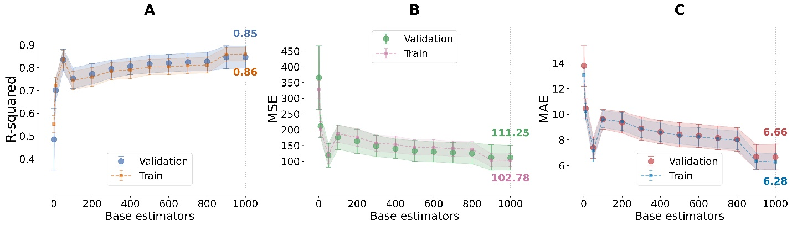
Figure 6 Performance metrics of the Stacked Ensemble at various base estimators from 1 to 10 to 50, 100 and up to 1000 of the tree-base algorithms.
Although in the stacked models there is a minor underfitting, these are still displaying better performances than the individual algorithmic models (see Supporting Information section 4, Figure S12, Figure S13 and Figure S14). The final model (1000 base estimators in tree-based algorithms) has improved significantly from their base models (see Table 5), with the exception of GBR, which had very low MAE value for training datasets. This could mean that the meta-features generated by the base models together with the application of Ridge regression as a meta-model, have successfully captured generalizable patterns in the data while maintaining good performance across both training and validation sets. The stacking approach has effectively leveraged the strengths of each individual model, combining their predictions in a way that mitigates their individual weaknesses. There is also the question of what is the limit of the number of base estimators and the improvements that can be brought by increasing to more than 1000 base estimators. In the case of reference ^{[17]}, 1000 base estimators were used with the aim of getting sufficiently smooth statistics. Based on the current results, we expect a smaller number of base estimators (i.e., 50), may have sufficed as well, though it should also be noted that the dataset used in the earlier study was significantly smaller, with fewer than 50 data points. The trend observed in Figure 6 (C), suggests an asymptotic effect, with the MAE approaching zero. However, adding more base estimators also increases training time and demands greater computational resources.
Table 5 Performance metrics of the individual models and the stacked ensemble of the selected model. Generalizability represents the difference between the Validation MAE and the Training MAE, where a negative value means it underfits and a positive value it overfits.
 | Training |  |  | Validation |  |  | Generalizability
Model | R² | MSE | MAE | R² | MSE | MAE | Validation MAE – Training MAE
GBR | 0.99 | 5.37 | 1.17 | 0.28 | 517.56 | 15.35 | 14.18
RF | 0.91 | 64.44 | 5.75 | 0.36 | 457.36 | 15.23 | 9.48
SVR | 0.50 | 364.76 | 14.02 | 0.35 | 462.02 | 15.95 | 1.93
Lasso | 0.30 | 515.25 | 18.91 | 0.17 | 590.25 | 19.85 | 0.94
ElasticNet | 0.38 | 451.78 | 16.83 | 0.23 | 539.28 | 18.34 | 1.51
Stacking Ensemble | 0.86 | 102.78 | 6.28 | 0.85 | 111.25 | 6.66 | 0.38

Evaluation of Model Fit and Residual Distribution
Based on the model performance study in section 3.3, we selected the stacked model that included 1000 base estimators for the tree-based algorithms and evaluated the model fit and residual distribution. Figure 7 (A) shows a strong linear relationship between the predicted and actual values for the T_{g}, with a Pearson correlation coefficient of 0.99. Most points fall very close to the ideal fit line, indicating good overall prediction accuracy across the range of values. From a model fit perspective, the close alignment of both predicted and actual points along the ideal fit line suggest the model has captured the underlying pattern in the data well. There is no obvious systematic bias visible, as points are evenly distributed above and below the line across the entire range. The model appears to perform consistently across a wide range of values, from approximately, -10 °C to 100 °C. This suggests robustness in handling both low and high values in the dataset. Figure 7 (B) provides additional insights into the model performance. The residuals appear roughly symmetrically distributed around the zero line, which is a positive indicator. This demonstrates the model is not systematically over or under predicting. There is a relatively consistent spread of residuals across the predicted values, indicating constant variance (homoscedasticity), which is a desirable property.
Figure 7 Regression plot of the selected stacked ensemble (at 1000 base estimators in the tree –based algorithms). Pearson correlation coefficient: 0.99, this value indicates a very strong positive linear relationship.

Mapping data
We used bivariate distribution plots to analyze the mapping data (Figure 4). High-density regions appear as peaks, while low-density areas form troughs. High-density areas indicate strong, confident predictions, whereas low-intensity peaks suggest sparse data or uncertainty. This pattern often emerges in imbalanced datasets, where one group of T_{g} values significantly outnumbers others.^{[36]} Consequently, the majority group dominates the density estimation, producing prominent peaks, while less distinct features may represent the minority group. Addressing the imbalanced dataset for small datasets through a classification or regression problem could be the subject of another study; in the interim, the current framework is sufficient for facilitating advancements in lignin PUs synthesis.
In Figure 8 (A) which shows the relationship between Lignin (wt%) and T_{g}, we can identify three distinct high-density prediction regions, namely: 55-60°C at 0-10 wt% lignin, 70-75°C at 20-30 wt% lignin and 60-70°C at 40-70 wt% lignin, respectively. Prediction uncertainty exhibits a marked increase above 20 wt% lignin content, with temperature variations spanning approximately 30 °C (50-80 °C). In contrast, the model demonstrates the highest prediction confidence in the 0-15 wt% lignin range, evidenced by minimal variance.
The presence of multiple high-density regions is characteristic of ensemble-based methods (RF and GBR algorithms). While smooth transitions between regions indicate robust interpolation capabilities, the prediction density patterns suggest potential overfitting, particularly in the 20-30 wt% and 40-50 wt% lignin regions where data clusters exhibit unusually high prediction density.
Several methodological limitations warrant consideration. Distinct discretization around 20-30 wt% lignin indicates potential sampling bias in the training dataset. The abrupt transition at 20 wt% lignin is characteristic of the boundary between distinct training data and as such it dictates a fundamental shift in the model's prediction mechanism. Sparse regions, visualized in yellow, as already mentioned, likely represent domains with imbalanced training data or physically improbable combinations of lignin content and T_{g}.
From a structure-property perspective, the relationships demonstrate complex behavior. This was captured earlier in the correlations of features analysis. Through mapping, we can observe how the initial T_{g} response (0-20 wt% lignin) exhibits a sharp increase from approximately 10 °C to 60 °C, attributed to higher crosslinking densities when the lignin content increases. The intermediate region (20-40 wt% lignin) achieves maximum T_{g} values of 75-80°C, with the highest prediction density at approximately 70°C, suggesting optimal molecular interactions between the rigid aromatic structures of lignin (enabling π-π stacking) and the hydrogen bonding network formed within the urethane linkages. These findings indicate that the optimal processing window lies between 15-25 wt% lignin for maximum T_{g} enhancement, while the 40-50 wt% range provides more consistent thermal properties.
In Figure 8 (B) through the analysis of Co-polyol type (PTHF) we reveal that the model's prediction density exhibits the highest confidence at T_{g} values around 60°C for each molecular weight cluster. The vertical distribution of predictions within clusters (spanning approximately 20-80 °C) indicates significant uncertainty, reflecting that not only the co-polyol molecular weight is determining for T_{g}, but also other parameters like the lignin/co-polyol ratio and the crosslinking density. The consistent pattern repetition across different molecular weights suggests the model has captured fundamental relationships between co-polyol size and thermal behavior.
In Figure 8 (C), which shows the Ratio [NCO]/[OH] influence, the model exhibits consistent prediction confidence bands centered primarily around 60 °C, with secondary patterns at T_{g} values of 50 °C and 80 °C. The regular oscillatory pattern in prediction density suggests the model has captured fundamental periodic relationships between stoichiometry and thermal properties.
In Figure 8 (D), the co-polyol content demonstrates a complex evolution, with the initial high-density region at 0 wt% gradually transforming into multiple discrete temperature domains as concentration increases, indicating a sophisticated structure-property relationship. Figure 8 (E) reveals the most intricate behavior through isocyanate concentration mapping, showing continuous density distributions predominantly in the 50-70 °C range, with maximum intensity observed at 10-15 mmol NCO. The presence of horizontal banding and the increasing pattern complexity at higher concentrations suggests multiple competing mechanisms influencing the thermal behavior. In contrast, Figure 8 (F) illustrates that the relationship between Tin(II) octoate concentration and T_{g} exhibits four well-defined, periodic regions of high probability centered at approximately 60-65 °C, occurring at regular intervals (0.0, 0.4, 1.0, and 1.4 concentrations as define in the input parameter grid). The influence of Swelling ratio (%) feature is shown in Figure S15 in the Supporting Information section 5.
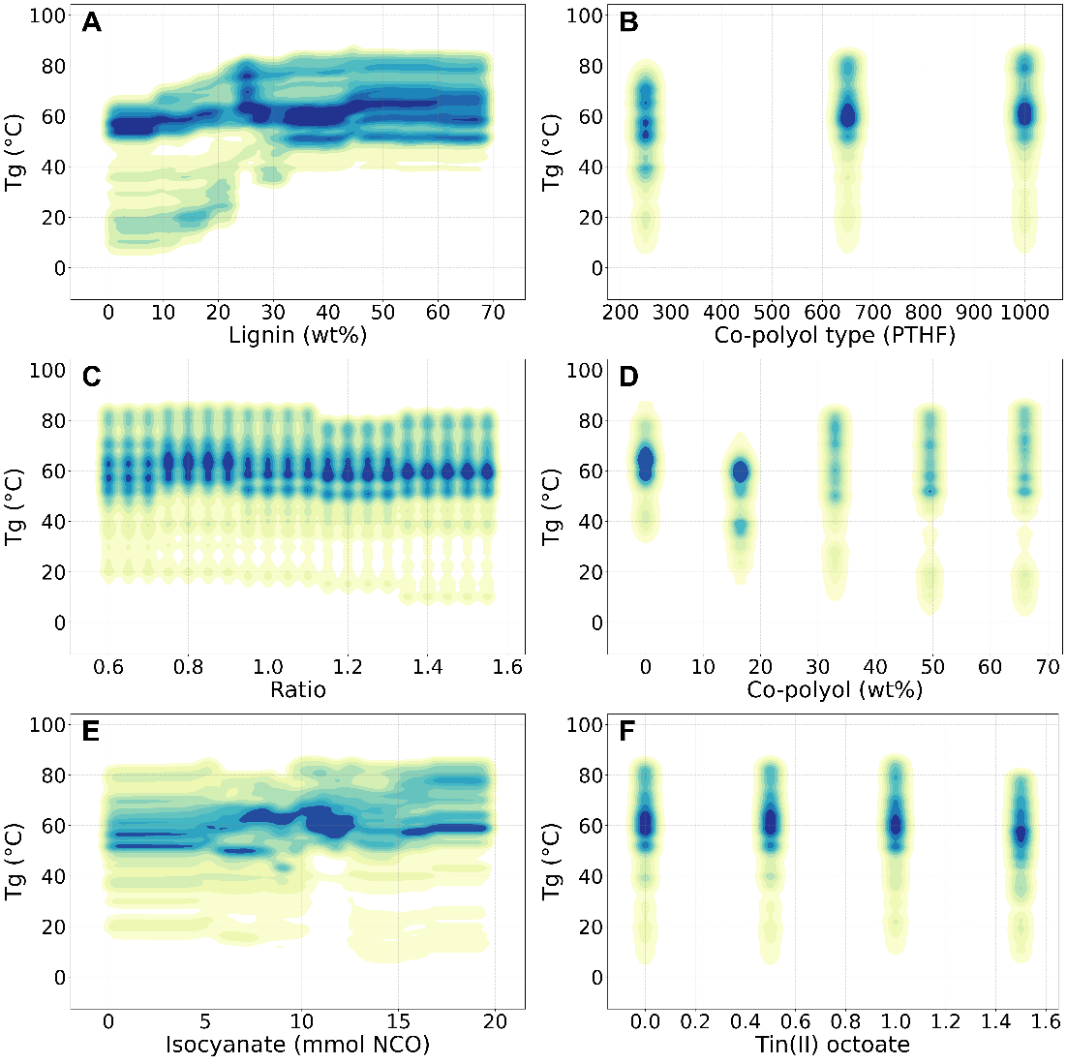
Figure 8 Kernel density estimation (KDE) with a Gaussian kernel and 10 contour levels was used to approximate the probability density function of the mapping data.
In addition, we can also see the tendency of the model predictions in the overall target frequency distribution (Figure S16, Supporting Information section 5). This data shows a strong peak around 73 °C, with frequencies reaching approximately 273,000 predictions in this region. The distribution is notably skewed, with higher frequencies concentrated between 40 °C and 80 °C, while predictions below 0 °C are relatively sparse. The same histogram demonstrates that the model makes the most predictions in the range of 60-80 °C, with a gradual decline in frequency towards both lower and higher temperatures. The frequency drops significantly for predictions below 0 °C and shows lower confidence in extreme temperatures, particularly in the negative range. To address this issue, future studies could focus on correcting the imbalance or expanding the dataset through synthetic augmentation.

Extrapolation
Beyond analyzing our model's performance within the known temperature range, we tested its ability to predict T_{g} in the low boundary regions of our dataset (Figure 9). Using an adaptive grid search method that refined broad intervals into precise results, we explored predictions from -17 °C to 100 °C. As shown in the regression scatter plot (Figure 7), the model performed well within the majority of the trained range. However, extrapolation led to a noticeable decline in performance beyond certain thresholds (i.e., -7 °C and 97 °C). The model retained accuracy for points closest to the range boundaries; but as predictions extended further beyond these boundaries, its output became increasingly linear and less reliable. These limitations are well-documented in the literature, even with other models and architectures such as NN and linear regression models.^{[37]}
Figure 9 Extrapolation of T_{g} between -17 °C and 100 °C. The bottom range predicts on target until the -7 °C data point. In the upper range the model extends accurate predictions up to 97 °C. The original dataset had four negative T_{g} values, (-11 °C, -16 °C x2, -17 °C), and the highest positive T_{g} values being 88 °C, 93 °C and 100 °C.

User Interface
The development of a model capable of accurately predicting the T_{g} represents a significant advancement in lignin-based PU formulations. However, a notable challenge persists: the accessibility and usability of such models for practicing chemists. To address this gap, we propose implementing a parallel coordinates plot as an intuitive and effective user interface. This visualization technique enables chemists to interact with the ensemble model and interpret data generated through the adaptive grid search algorithm.
The parallel coordinates visualization technique presents several key advantages for analyzing T_{g} formulation spaces. This methodology enables the simultaneous representation of multiple dimensional parameters, providing researchers with a comprehensive visualization of the complex variable interactions that influence T_{g} behavior. Through dynamic filtering capabilities, researchers can systematically explore specific parameter ranges, thereby facilitating the rational identification of optimal formulation conditions. Furthermore, the parallel coordinates representation elucidates both direct and inverse correlations between formulation parameters, offering valuable insights into the underlying physicochemical relationships that govern the glass transition phenomenon. This visualization approach proves particularly valuable for understanding the multifaceted interplay between composition, processing conditions, and resulting thermal properties within the formulation space
In Figure 10, we implemented data points with T_{g} values between -7 °C and up to 97 °C. This decision was based on observed reduced accuracies in extrapolated predictions beyond these boundaries. By constraining the model to this range, we ensured more reliable predictions within the most practically relevant temperature span. Another example for formulations containing 100 wt% Lignin is shown in the Supporting Information, section 6.
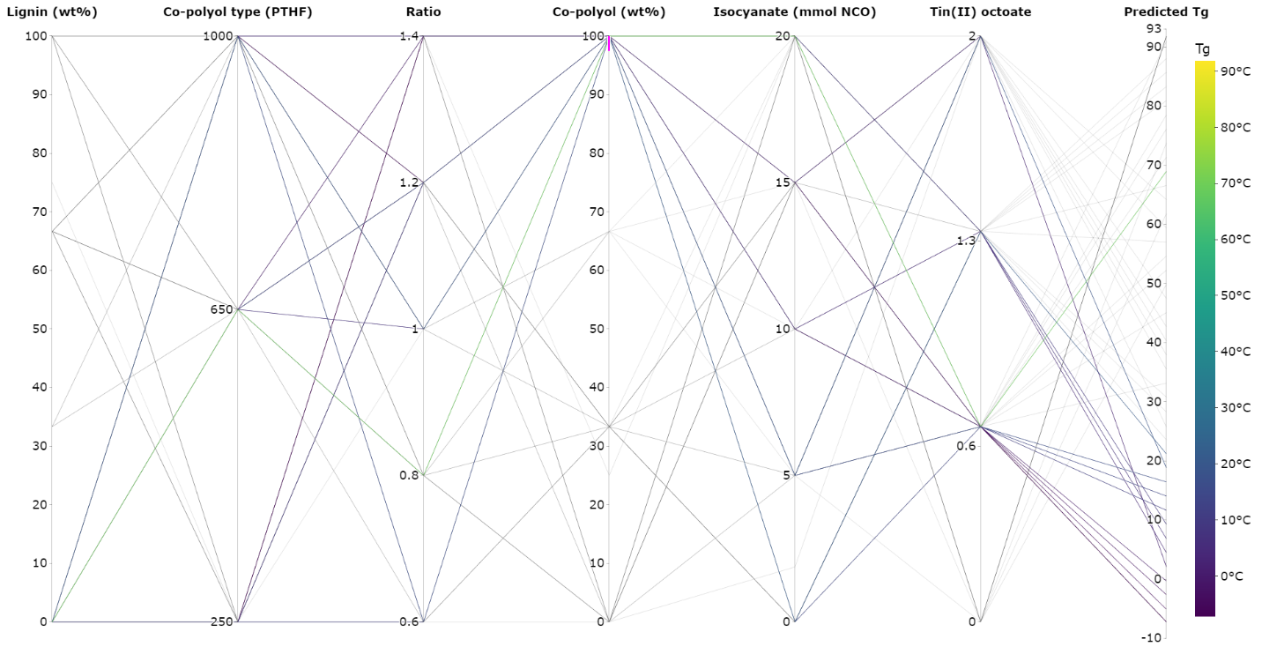
Figure 10 Parallel coordinate plot using the predictions generated by the ensemble ML model from the adaptive grid search study predicting T_{g} of 100 wt% Co-polyol.
Having presented all the results and returning to the central question of this study, we can confidently conclude that ML can effectively predict the synthesis formulation of lignin PUs. We have demonstrated this capability specifically for the T_{g}.
Moreover, this method can be applied to a wide array of materials science and chemistry, such as predicting the mechanical strength, thermal conductivity or electrical properties of novel materials.^{[38,39]} This is a particularly useful alternative to deep-learning techniques, which are commonly used in this domain, but fall short on low-data regimes.^{[40]}

Conclusion
Our analysis revealed that lignin is a major contributor to enhancing the T_{g} of the lignin PUs. Interestingly, co-polyol content exhibited a complex relationship with T_{g}, showing a negative correlation overall but demonstrating a positive influence relative to other features. The swelling ratio emerged as a critical characterization parameter, exhibiting the highest contribution in terms of absolute loading in PCA. These findings underscore the importance of comprehensive material characterization in developing accurate predictive models for lignin-based PUs.
The performance of the ML models improved significantly with the inclusion of the swelling ratio values as additional feature. Ensemble learning techniques demonstrated varying performances based on the number of estimators, with higher numbers generally yielding better results. The best-performing models achieved a MAE of 6.66 °C with generalizability of 0.38, indicating a slight overfitting of the data. The selected model demonstrated restricted extrapolation capabilities beyond its training domain. This limitation emphasizes the importance of careful consideration when applying these models to underrepresented conditions or scenarios outside their training range. For visualization, parallel coordinates proved to be a meaningful technique for this dataset, given the relatively small number of features.
Returning to the central question of this study, we demonstrated that the ML model predicts and optimizes the formulations of lignin PUs, while using limited experimental datasets with high accuracy. Despite the promising results, several limitations of this study must be acknowledged. The small experimental dataset may have constrained the models' ability to capture the full complexity of lignin PU synthesis. The limited extrapolation range restricts the models' applicability to a narrow temperature window outside the training data. Additionally, the observed overfitting suggests that further optimization of ML techniques for small datasets is necessary. Future research should focus on expanding the experimental dataset, incorporating a wider range of lignin sources, synthesis conditions, and characterization parameters to improve model robustness and generalization. Advanced feature engineering techniques, including non-linear transformations and interaction terms, should be investigated to capture complex relationships within the data. The integration of physics-based models with ML techniques could leverage domain knowledge and potentially improve extrapolation capabilities.

Acknowledgements

This work was supported by the Research Foundation – Flanders (FWO) under grant G0E0223N digiLignin.

Author contributions
Silviu Florin Acaru: Conceptualization, Data curation, Formal analysis, Investigation, Methodology, Validation, Visualization, Writing – original draft
Marc Comí: Conceptualization, Data curation, Formal analysis, Investigation, Methodology, Writing – original draft
Panagiotis Falireas: Conceptualization, Data curation, Formal analysis, Investigation, Methodology
Danny E. P. Vanpoucke: Funding acquisition, Project administration, Resources, Writing – review and editing
Richard Vendamme: Conceptualization, Methodology, Funding acquisition, Project administration, Resources, Supervision, Writing – review and editing
Katrien V. Bernaerts: Conceptualization, Methodology, Funding acquisition, Project administration, Resources, Supervision, Writing – review and editing

Conflict of Interest
The authors declare no conflict of interest.
Data Availability Statement
The data that support the findings of this study are available in the supplementary material of this article.

References
[1] A. Delavarde, G. Savin, P. Derkenne, M. Boursier, R. Morales-Cerrada, B. Nottelet, J. Pinaud, S. Caillol, Sustainable polyurethanes: toward new cutting-edge opportunities, Vol. 151, Elsevier Ltd, 2024.
[2] J. Brzoska, J. Smorawska, E. Głowińska, J. Datta, Ind Crops Prod 2024, 222.
[3] M. Comí, M. Fernández, A. Santamaría, G. Lligadas, J. C. Ronda, M. Galià, V. Cádiz, Macromol Chem Phys 2017, 218.
[4] M. Comí, G. Lligadas, J. C. Ronda, M. Galià, V. Cádiz, Polymer (Guildf) 2016, 103, 163.
[5] M. Comí, G. Lligadas, J. C. Ronda, M. Galià, V. Cádiz, Eur Polym J 2017, 91, 408.
[6] E. Pichon, D. De Smet, P. Rouster, K. Freulings, A. Pich, K. V. Bernaerts, Mater Today Chem 2023, 34, 101822.
[7] E. Pichon, J. Verstappen, S. Stepanova, A. Pich, K. V. Bernaerts, Eur Polym J 2024, 217, 113309.
[8] B. G. Laycock, C. M. Chan, P. J. Halley, Prog Polym Sci 2024, 101874.
[9] C. Kim, R. Batra, L. Chen, H. Tran, R. Ramprasad, Comput Mater Sci 2021, 186, 110067.
[10] I. P. Malashin, V. S. Tynchenko, V. A. Nelyub, A. S. Borodulin, A. P. Gantimurov, Polymers (Basel) 2024, 16, 1-27.
[11] A. U. Hassan, S. S. A. Shah, H. M. Abo-Dief, S. Naeem, N. Khan, E. Alzahrani, Z. M. El-Bahy, Synth Met 2024, 307, 117659.
[12] A. Alesadi, Z. Cao, Z. Li, S. Zhang, H. Zhao, X. Gu, W. Xia, Cell Rep Phys Sci 2022, 3, 100911.
[13] J. Leem, Y. Jiang, A. Robinson, Y. Xia, X. Zheng, Adv Funct Mater 2023, 33, 2304451.
[14] B. Dou, Z. Zhu, E. Merkurjev, L. Ke, L. Chen, J. Jiang, Y. Zhu, J. Liu, B. Zhang, G. W. Wei, Machine Learning Methods for Small Data Challenges in Molecular Science, Vol. 123, American Chemical Society, 2023, pp. 8736–8780.
[15] J. M. Weber, Z. Guo, C. Zhang, A. M. Schweidtmann, A. A. Lapkin, Chemical data intelligence for sustainable chemistry, Vol. 50, Royal Society of Chemistry, 2021, pp. 12013–12036.
[16] L. Tao, V. Varshney, Y. Li, Benchmarking Machine Learning Models for Polymer Informatics: An Example of Glass Transition Temperature, Vol. 61, American Chemical Society, 2021, pp. 5395–5413.
[17] D. E. P. Vanpoucke, O. S. J. Van Knippenberg, K. Hermans, K. V. Bernaerts, S. Mehrkanoon, J Appl Phys 2020, 128, 054901.
[18] D. E. P. Vanpoucke, M. A. F. Delgove, J. Stouten, J. Noordijk, N. De Vos, K. Matthysen, G. G. P. Deroover, S. Mehrkanoon, K. V Bernaerts, Polym Int 2022, 71, 966.
[19] R. Q. Albuquerque, F. Rothenhäusler, H. Ruckdäschel, MRS Bull 2024, 49, 59.
[20] H. Esmaeili, R. Rizvi, Comput Mater Sci 2023, 229, 112432.
[21] A. Milad, S. H. Hussein, A. R. Khekan, M. Rashid, H. Al-Msari, T. H. Tran, Eng Comput 2022, 38, 3625.
[22] Y. Zhao, R. J. Mulder, S. Houshyar, T. C. Le, A review on the application of molecular descriptors and machine learning in polymer design, Vol. 14, Royal Society of Chemistry, 2023, pp. 3325–3346.
[23] S. Zhan, W. Huang, C. Dong, Q. Chen, H. Zhao, P. Duan, A. Hu, Q. Li, Y. Li, J. Liu, L. Zhang, Mater Today Commun 2024, 40, 110181.
[24] S. Shirazian, T. Huynh, S. M. Sarkar, M. Habibi Zare, Polym Test 2024, 137, 108525.
[25] H. Abdi, L. J. Williams, Principal component analysis, Vol. 2, 2010, pp. 433–459.
[26] S. F. Acaru, R. Abdullah, D. T. C. Lai, R. C. Lim, Heliyon 2022, 8, e10738.
[27] T. G. Dietterich, In Multiple Classifier Systems, Springer, Berlin, Heidelberg, 2000, pp. 1–15.
[28] I. D. Mienye, Y. Sun, A Survey of Ensemble Learning: Concepts, Algorithms, Applications, and Prospects, Vol. 10, Institute of Electrical and Electronics Engineers Inc., 2022, pp. 99129–99149.
[29] P. Ortiz-Serna, M. Carsí, M. Culebras, M. N. Collins, M. J. Sanchis, Int J Biol Macromol 2020, 158, 1369.
[30] P. Jutrzenka Trzebiatowska, A. Santamaria Echart, T. Calvo Correas, A. Eceiza, J. Datta, Prog Org Coat 2018, 115, 41.
[31] J. R. Gouveia, R. R. de Sousa Júnior, A. O. Ribeiro, S. A. Saraiva, D. J. dos Santos, Eur Polym J 2020, 131, 109690.
[32] M. Wadekar, W. Eevers, R. Vendamme, Ind Crops Prod 2019, 141, 111655.
[33] J. Shi, T. Zheng, Y. Zhang, B. Guo, J. Xu, Polym Chem 2021, 12, 2421.
[34] F. Levine, J. Escarsega, J. La Scala, Prog Org Coat 2012, 74, 572.
[35] G. I. Webb, Z. Zheng, IEEE Trans Knowl Data Eng 2004, 16, 980.
[36] S. Das, S. S. Mullick, I. Zelinka, IEEE Transactions on Artificial Intelligence 2022, 3, 973.
[37] A. Babbar, S. Ragunathan, D. Mitra, A. Dutta, T. K. Patra, Journal of Polymer Science 2024, 62, 1175.
[38] X. Hong, Q. Yang, K. Liao, J. Pei, M. Chen, F. Mo, H. Lu, W. Bin Zhang, H. Zhou, J. Chen, L. Su, S. Q. Zhang, S. Liu, X. Huang, Y. Z. Sun, Y. Wang, Z. Zhang, Z. Yu, S. Luo, X. F. Fu, S. L. You, AI for organic and polymer synthesis, Science China Press, 2023.
[39] H. Jang, D. Ryu, W. Lee, G. Park, J. Kim, Mol Syst Des Eng 2024, 9, 959.
[40] D. van Tilborg, H. Brinkmann, E. Criscuolo, L. Rossen, R. Özçelik, F. Grisoni, Deep learning for low-data drug discovery: Hurdles and opportunities, Vol. 86, Elsevier Ltd, 2024.

